EMCH361 Mechanical Engineering Laboratory I, Spring 2022

Laboratory 1
HARDNESS TESTS

Brown, Ryan
Section 004
Email: rb23@email.sc.edu
02/09/2022
Department of Mechanical Engineering
University of South Carolina
Columbia, SC 29208

Abstract

Hardness is a measurement of a materials ability to resist change under a given load. Hardness is important to engineers because it gives a sense of how strong certain materials are and their properties under a load. The lab tests the hardness of an unknown material by indenting on the surface and measuring the geometry of the indent. For the hard material the Vickers Micro Indenter was used, and for the rubber-like material a durometer was used. Once the indent was made with the Vickers micro indenter, measurements were taken by the students, followed by calculating statistics regarding the measurements found. The durometer measurements operated in a similar fashion, by reading the output on the durometer and calculating the statistics surrounding those measurements. Using formulas provided to the students, a hardness number is calculated and then checked against a chart to find out what the unknown metal was. Similarly, the measurements from the durometer were checked against a chart to find out what the unknown material was. These results show the students how to accurately measure and the proper protocol for gathering data and forming conclusions.

introduction

Hardness is a fundamental property of engineering materials. The hardness value tells the engineer how likely or good a material is at resisting change. [1] The deformation being evaluated is the plastic deformation of the object, its permanent change after a load or stress has been applied. One of the major advantages of using the Vickers tester is size. Most other variations of hardness testers are large and take up too much floor space, however the Vickers tester sits on the tabletop. Another advantage is the size of the indention. Vickers creates a microscopically small indention in the material that would then be read in the unit of micrometers. This small of an indentation on a material is considered non-destructive and is desired in beginner applications of hardness testing.
When using the Vickers tester, a distance is collected and then input into a given formula. The formula:

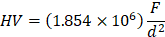
(1)

is used to calculate the hardness value. The variable ‘F’ represents the applied load to the specimen, and the variable ‘d’ refers to the average of the two diagonal measurements recorded from the microscope. The data obtained in the experiment should be recorded in kg_{f} per μm².
The durometers experiment should be carried out slightly different. The durometers directly measure the hardness of the rubber material, therefore the value displayed on the dial is the hardness of the material. There are different types of durometers the most common being Shore A and D. The durometers work by measuring the materials resistance to permanent change, this is done by applying a load to a pen and then measuring the resistance of the material[3]. No conversion needs to be done with a durometer because it automatically outputs a hardness value. Different shores of durometer are used depending on the hardness of the material. If a material is too hard and very resistant to change then a decision needs to be made on which durometer to use.
Using the mean, standard deviation, and confidence interval equations an average hardness value is able to be calculated within a given uncertainty. The equations are as follows:
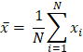
(2)

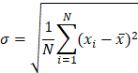
(3)

(4)

Once the hardness values have been obtained, an assumption can be made as to what the unknown specimen is made of.
In real applications, a small sample of the known material would be obtained and tested. This gives an engineer an idea of how hard/strong the material they are using is. This is important when building mechanisms or structure in which stresses or strains are applied, and an adequate material is to be selected. The variables in equation 1 are inversely related, therefore the smaller the indention, the greater the hardness value. Similarly, the larger the force applied, with minimal variable d change, the greater the hardness value.

instruments

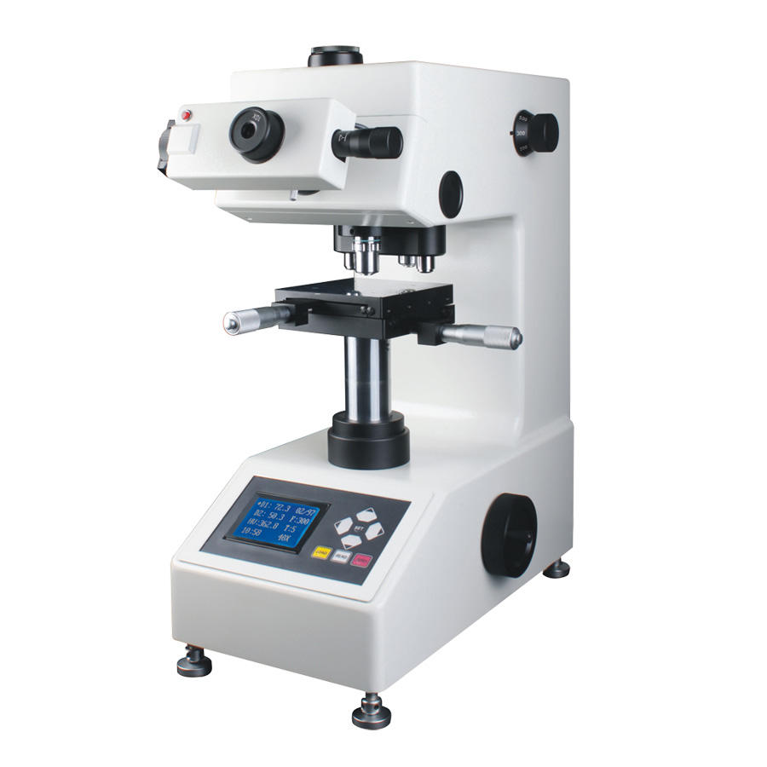
Figure 1: Vickers Microhardness Tester [2]

The device used to measure the hardness of harder materials is shown above. This is known as the Vickers hardness tester, and it works by making an indention in the material and then measuring the diagonal distances. The one used in lab had knobs on the side to adjust the indention time and the load applied. The Vickers hardness tester is special because it applies loads less than one kilogram force, this combined with this microscopic indention are why this device is considered nondestructive. The big knob on the side adjusts the focus of the microscope found on the turret. The turret contains three tools, a 10X microscope, 40X microscope and the indenter. The turret is located on the bottom of the device head.
Located directly under the turret is a component called the stage. The stage is where the specimen is loaded and locked into place. The stage can be adjusted with the two knobs located on the front and right side. Twisting the knobs, the specimen can accurately be brought into view of the microscope. The microscope is located on the front of the device head, it contains a micrometer so that the engineer can accurately measure the distance between the diagonal points.

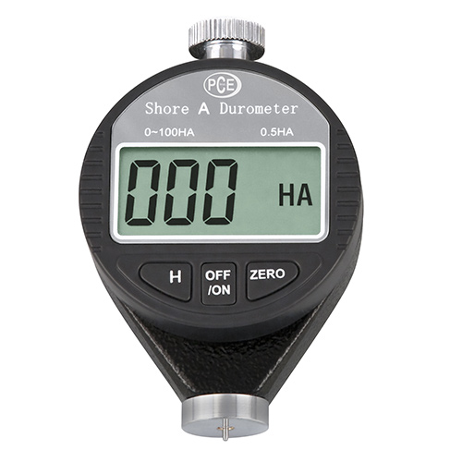
Figure 2: Durometer [4]

The device used to measure hardness of softer materials, such as rubber, is pictured above. This is known as a durometer, and it directly gives the hardness value of the material. There are many different versions of this tool, called shores, but the most common being shore A and shore D. This device uses the pin seen on the bottom to create an elastic indention in the material and then measures it versus the applied load to the material.

procedures

Starting with the Vickers hardness tester, the device should be accurately calibrated and ensured that it is sitting on a level surface. Next the machine is powered on. The specimen should be placed on the stage and secured in place, ensuring that the specimen is clean and fits the parameters of specimen size indicated by the Vickers machine. The turret is then rotated to the 10X microscope, and the knobs found on the stage are used to locate an area on the specimen that is clear of indentions or facial disturbances. The knobs on the side that indicate applied load size and indention time should be changed to one kilogram force and five seconds respectively. The stage is pulled out and the turret is rotated to the indenter tool, and the stage is returned to its original state carefully. The start button located on the front of the device is pressed and the intention is made. A green indicator light will come on when the indention process starts then the light will turn off when it is over. Once the green light turns off, the stage is pulled away and the indenter tool is switched to the 10X microscope, and the stage is returned to its original position carefully. The indention is located by looking through the microscope and using the knobs on the stage to center it as best as possible. The stage is pulled away one more time and the turret is rotated to the 40X microscope the stage is then carefully returned to its original position. Upon looking into the 40X microscope, the indention can be seen and needs to be centered using the knobs on the stage. Two lines visible in the lens of the 40 times microscope, these should be aligned with the corners of the indention made. The knob on the left adjusts the zero side of the two lines, the knob on the right, the micrometer, adjusts the right line to get an accurate measurement of the two diagonal points. The length being measured should be perpendicular to the left and right lines to ensure the best measurement. Once the indention is lined up between the two lines in the magnifying lens, read the micrometer and record the measurement. This is considered R1. Rotate the microscope 90 degrees so that the lines line up with the second set of diagonal points. Repeat the process and record the measurement found. This is considered R2. All measurements recorded in the 40X microscope are in micrometers. After R2 is recorded, find the average value between R1 and R2 and record this value as variable ‘d’. This completes one measurement. This process is repeated 25 times and recorded.
Using the durometer is considerably simpler. A durometer is obtained based on the initial assumption of how hard the material is. What's the correct durometers has been obtained, begin by turning the device on. Three zeros will appear on the screen. Place the specimen on a level flat surface. Hold the durometer in one hand and hover it above the specimen. The zero button on the durometer should be pressed followed by lowering the durometer down and pushing it into the specimen. The button on the top should then be pressed, this applies the load to the specimen. A reading should show up on the display, record this reading and remove the durometer from the specimen. This process should be repeated 25 times.

Numerical analysis and results

The results found in the experiment were recorded and then implemented into an excel file. Using the excel file hardness values, as well as a statistical analysis can be done. Using equations (1,2,3,4) accurate results can be produced and the unknown specimen should confidently be able to be identified.
After setting up for the lab the experiment, the lab may start, initially beginning by using the Vickers and then moving to the durometer. The order does not matter but if working in large groups this is the fastest method. Being careful to line up the micrometer lines as consistently as possible is important as the true value of the indention width does not change. However, human error may occur in these measurements.

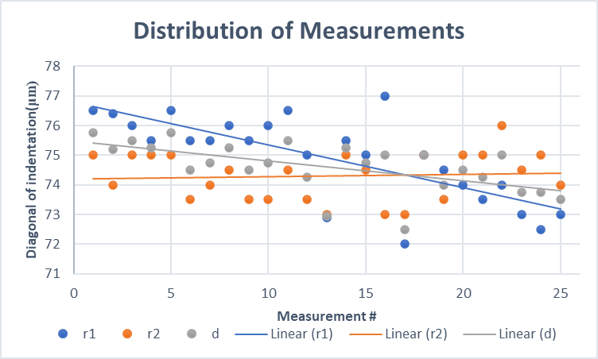
Figure 3: Distribution of Measurements

Following the procedures leaves twenty-five variable R1, R2, and d measurements. In figure 3, the distribution of these measurements is shown. the value ‘d’ is dependent upon the average of R1 and R2 of each measurement. After the ‘d’ values were found, using equation (1), the value can be converted from a measurement to a hardness value. The chart below shows the ‘d’ value before the equation was applied and the ‘HV’ (hardness value) number after the equation.

d | HV
75.75 | 323.106
75.2 | 327.849
75.5 | 325.249
75.25 | 327.414
75.75 | 323.106
74.5 | 334.039
74.75 | 331.808
75.25 | 327.414
74.5 | 334.039
74.75 | 331.808
75.5 | 325.249
74.25 | 336.292
72.95 | 348.385
75.25 | 327.414
74.75 | 331.808
75 | 329.600
72.5 | 352.723
75 | 329.600
74 | 338.568
74.5 | 334.039
74.25 | 336.292
75 | 329.600
73.75 | 340.868
73.75 | 340.868
73.5 | 343.190
Figure 4: ‘d’ Value and ‘HV’ Values

The ‘d’ value in equation (1) is in micrometers and the ‘F’ value was the load applied, recorded in kilogram force. This produces a list of twenty-five hardness values that depends on the calculated average value ‘d’. Using equation (2), the mean is found to be equal to 333.3121 kgf/mm². After finding the mean the standard deviation can be found by using equation (3). The variable x_{i} refers to each hardness value measurement, and N being the number of measurements taken. The standard deviation is found to be 7.4382 kgf/mm². The given confidence interval that the students were assigned to find was eighty percent confidence. This means that the student is eighty percent confident that the true value lies between the two found values. To find these values equation (4) is used. [5] The z-score value for an eighty percent confidence interval is 1.28. using z-score, mean, and standard deviation the final eighty percent confidence interval is determined to be:

(323.6922 ≤ x ≤ 342.734) kgf/mm²

REFERENCES
[1] Corrosionpedia. “What Is Hardness of Materials? - Definition from Corrosionpedia.” Corrosionpedia, Corrosionpedia, 21 Oct. 2020, https://www.corrosionpedia.com/definition/620/hardness-of-materials-material-resistance.
[2] “Micro Vickers Hardness Tester Microhardness Measurement.” Sinowon, https://www.sinowon.com/vexus-mhv-1000z-series-advanced-digital-micro-vickers-hardness-tester.
[3] “Measuring the Durometer (Hardness) of a Conveyor Belt.” Sparks Belting, 3 Apr. 2017, http://www.sparksbelting.com/blog/measuring-the-durometer-hardness-of-a-conveyor-belt.
[4] PCE Americas Inc. : Test Instruments. “Durometer PCE-Dd-a Shore a.” Durometer PCE-DD-A Shore A | PCE Instruments, 12 Feb. 2022, https://www.pce-instruments.com/us/measuring-instruments/test-meters/durometer-shore-durometer-pce-instruments-durometer-pce-dd-a-shore-a-det_2131527.htm.
[5] Table 3.2 from blackboard

